**No Touch Bird Calls Display**

**Final Technical Report**

**Senior Design III - SD1319**

**Spring 2014**

Andrew Widmer, Jake Schulzetenberg, Thomas Schwandt

Faculty Advisor: Dr. Jacob Glower

Table of Contents

Pictures of Device 3

Introduction and Background 4

Requirements (necessary and voluntary) 5

Requirements Fulfilled 6

Process, Deciding Project Definition and Objective 4

Design Methods and Decisions10-28

Design Methods and Decisions –Part Selection 10

Design Methods and Decisions - Hardware Design / Schematic 16

## Design Methods and Decisions – Software Design23

Design Methods and Decisions – Enclosure Design28

Project Development Timeline29

Budget30

Troubleshooting Section – Technician’s Guide30

Project Comments31

Conclusion33

Special Thanks33

Appendix34

## Pictures of Device

## 

## 

**Inside Unit (above)**

## 

**Outside Unit (above)**

## Introduction and Background

This is the final technical report for Senior Design Group SD1319. Group members include Thomas Schwandt, Andrew Widmer, and Jacob Schulzetenberg. The Faculty Advisor is Dr. Jacob Glower. The project is being created directly for Dr. Glower who in turn will be presenting the product to a colleague at the Red River Zoo to be donated and used by the zoo.

The project’s title is the “No Touch Bird Calls Display”. The scope of the project comes from the idea that we’d like to create a display that can be used without requiring physical touch from the user. The problem being that when things are subject to extensive physical touch, especially something that would be in the presence of large amounts of foot traffic, they have the tendency to require maintenance and repair because of the wear and tear they sustain with hands on use. Creating a display that does not require any physical touch should negate the need for maintenance and repair for those physical devices. As long as the device uses technology that is reliable with a long electronic life span the need for maintenance should be largely eliminated.

Beyond the non-physical requirements, the display would activate audio sounds that would be related to the birds used at the red river zoo.

This technology necessary for a project like this is obviously present today. In research done initially, there wasn’t an application using electronics and non-physical activation that could be found used in zoos. It is difficult to research something like this as many zoos would not list or report the use of such things on a website. Although this direct application wasn’t found, we know that there are different applications involving non-physical activation such as motion activated sensors, etc. They are used for different purposes than ours but the basic idea is commonly used in electronic technology today.

## Process, Deciding Project Definition and Objective

The group met with our advisor extensively in the beginning months of this year. At the time the group had less knowledge about electronics and managing a project with embedded systems. The group discussed with the advisor about the different routes we could take to accomplish our project. It was exciting to talk about the various paths the group could take, the main objective was known but the route to get there was left to our design.

Initially, the group discussed using blue tooth technology for the display. Taking advantage of the large demographic of people having smartphones. The group talked about creating an app in addition to the display. The group talked about using an LCD screen in addition to the audio capabilities to display different information in regards to the animals, the weather, the conditions of the area, time, etc.

After much discussion the group decided upon the project definition and requirements for the project. The group knew that we would need to create a project that used non-touch sensors connected to a microcontroller that would activate audio sounds related to certain sensors locations in regards to the display. The group decided to not use Bluetooth related technology and smartphones because of the cost related to using apps, the complexity, and the demographic that we were creating the display for. This display would be used in a zoo and so would be used mainly by youth and younger aged children. The information desired from such a display would not be extensive or complex enough to really require the use of technology such as smartphones and Bluetooth, although this would be exciting and would allow for great capability potential.

The project definition can be described then as follows:

*A non-touch sensor activated zoo display that activates audio files that play audibly heard bird calls correlated to a poster display of birds from the Red River Zoo and surrounding region.*

The requirements decided upon including necessary requirements and voluntary requirements are included and described below.

## Requirements (necessary and voluntary)

These Requirements were decided upon and set in September of 2013.

1. Play a minimum of four different bird calls and have availability for expansion.
2. Volume should be at a level (dB) easy to hear in outside environment.

**Rugged Conditions Requirements**

1. Unit able to withstand various levels of temperature while maintaining full functionality, temperatures ranging from -25C to 50C.
2. Unit able to withstand various levels of relative humidity ranging from 10% to 100% while maintaining full functionality.
3. Unit should have some sort of protective enclosure so that unit functions under precipitation conditions i.e. rain or possibly snow.
4. Unit able to withstand various amounts of force due to children and humans interacting on display.

**Power Requirements**

1. 120 Vrms AC input Voltage
2. Average power consumption of unit, maximum of 15W

**Size Requirements**

1. From a marketing point of view, aesthetically pleasing so as to attract initial interest.
2. Width and length of a minimum of 50cm by 50cm to a maximum of 180 cm by 180cm.
3. Depth of less than 30 cm.
4. Unit able to be relocated easily due to a number of zoo reasons (including peak weather conditions)
5. Unit should have some sort of security system, locking it into place, preventing unauthorized removal
6. Unit should be less than 70 lbs. or 32 Kg.

**User Interface Requirements**

1. Should have an on and off switch capability to prevent power consumption during non-business and non-operation hours.
2. User interface including scrolling LCD display showing temperature, time date, humidity, etc., *
3. Sensors to activate the corresponding animal display sounds (such available sensors could be: passive infrared, light, motion, or any combination of these within the unit.)

*NOTE: The only Requirement that is voluntary in this list is this “*User interface including scrolling LED display showing temperature, time date, humidity, etc.,”* This is voluntary because it is not completely necessary and is not completely related to the functionality of the display’s audio capabilities.

## Requirements Fulfilled

1. Play a minimum of four different bird calls and have availability for expansion.

**Our display is capable of playing six different bird calls. These bird calls are stored on a micro SD card. Depending on the software chosen by the zoo the sounds could be changed to six new ones with the press of a button. The Audio playback chip used has the memory capable of playing 512 different sounds.**

1. 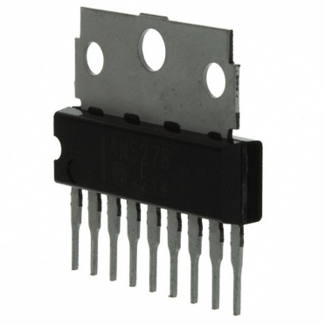Volume should be at a level (dB) easy to hear in outside environment.

**A power amplifier was added to increase the volume of the animal sounds. This power amplifier greatly amplifies the signal coming from the audio playback chip and has a max rating of 8W. A speaker is also used that can handle the amount of power across it with the use of this power amplifier.**

AN5278 Power amplifier shown at right.

**The speaker being used is capable of providing a max dB level of 86 dB. This is within proper volume levels to be heard in an outdoor environment without being harmfully loud.**

**Rugged Conditions Requirements**

1. Unit able to withstand various levels of temperature while maintaining full functionality, temperatures ranging from -25C to 50C.

**All Electronic Components used in this project are rated at temperatures with larger ranges than -25C to 50C.**

1. Unit able to withstand various levels of relative humidity ranging from 10% to 100% while maintaining full functionality.

**Unit will not have a problem dealing with various levels of humidity.**

1. Unit should have some sort of protective enclosure so that unit functions under precipitation conditions i.e. rain or possibly snow.

**Unit has protective enclosure. Display needs to be powered by a normal wall outlet. The power input to the unit is inside the display and so is sealed from the outside. The speaker needs to be able to send sound waves outside the unit. The enclosure has drilled holes allowing the sound to escape the unit. The speaker chosen is weatherproof for this very reason. The speaker is drilled to the enclosure so that precipitation cannot enter the enclosure this way. The poster designed showing different birds is weatherproof in case any precipitation does get in contact with it. This poster is behind a sheet of Plexiglas that covers the entire front of the display. Protecting the poster and sensors is a weatherproof foam sealant that runs around the edge of the enclosure. The sensors used need to see through drilled holes in the metal enclosure. These are behind and can see through Plexiglas and so will cause no weather problems. The metal enclosure has various corners that were not sealed; simple construction sealant was used to seal these openings.**

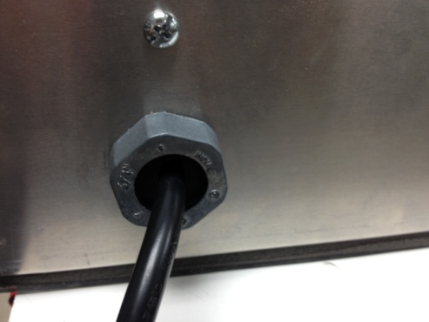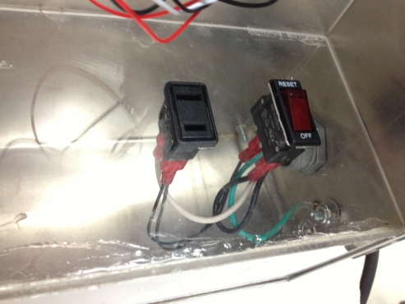

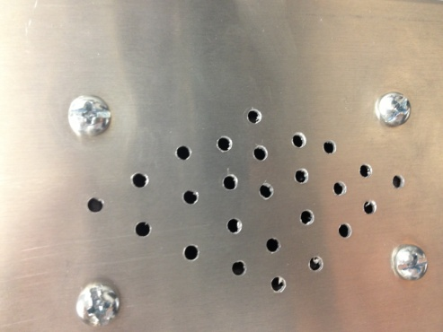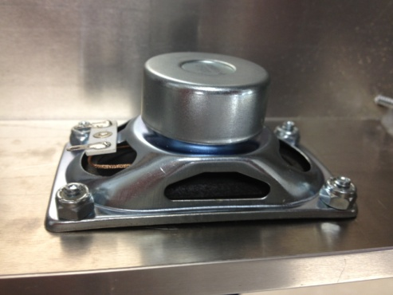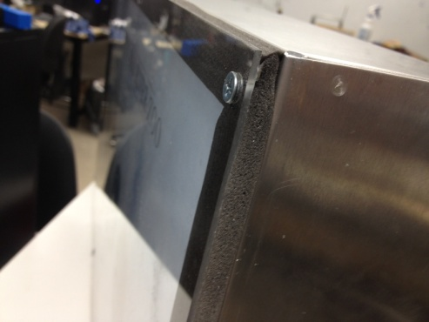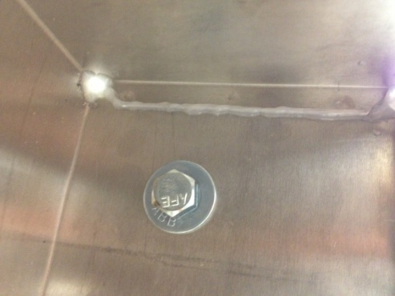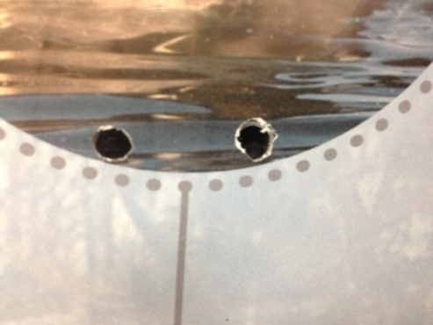

1. Unit able to withstand various amounts of force due to children and humans interacting on display.

**As stated above, the unit has a protective enclosure. The enclosure itself is made of aluminum metal. There is flexible Plexiglas in front of the poster. Plexiglas could be broken or bent in half but there is not enough area to bend the Plexiglas in order to cause damage. The Plexiglas is also screwed into the enclosure. The unit is able to withstand normal amounts of user force. The unit could be damaged if direct attempts were made to do so. Preventing these attempts was not the desire of our project requirements.**

**Power Requirements**

1. 120 Vrms AC input Voltage

**The unit’s power comes from a wall outlet. A basic wall outlet provides 120 Vrms AC input voltage. The unit uses a 120 Vrms AC voltage to 12V DC wall inverter to power the Product Control Board.**

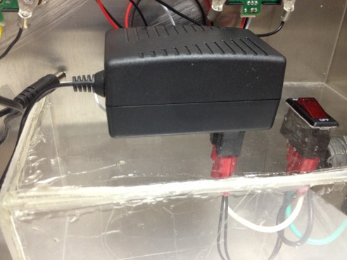

1. Average power consumption of unit, maximum of 15W

**The unit does not use more than 15W of power. The adapter is rated to provide a maximum of 12 W. The individual components of our pcb do not use more than 15W.**

**Size Requirements**

1. From a marketing point of view, aesthetically pleasing so as to attract initial interest.

**We believe the poster that was designed is aesthetically pleasing and relatively attractive to suit the product’s application.**

1. Width and length of a minimum of 50cm by 50cm to a maximum of 180 cm by 180cm.

**The dimensions of the unit are 75cm width by 43 cm height by 12 cm depth. These dimensions are suitable. Although the height is less than 50 cm that was the necessary height used based on available enclosures.**

1. Depth of less than 30 cm.

**The depth of the enclosure is only 12cm.**

1. Unit able to be relocated easily due to a number of zoo reasons (including peak weather conditions)

**The unit is not heavy or bulky, having a weight less than 15 kg. The chord is less than 5 meters long and can easily be wound up. The unit is attached and secured well inside the enclosure so as not to be incredibly fragile.**

1. Unit should have some sort of security system, locking it into place, preventing unauthorized removal.

**Ensuring that the unit is protected by theft concerns is up to the discretion of the Red River Zoo. The unit itself will have inside of enclosure access at the back of the unit to prevent outside interference with the inner electronics.**

1. Unit should be less than 70 lbs. or 32 Kg.

**Unit weighs less than 32 Kg.**

**User Interface Requirements**

1. Should have an on and off switch capability to prevent power consumption during non-business and non-operation hours.

**There is an on off switch, which is a breaker that can be used to turn the unit on or off.**



1. User interface including scrolling LCD display showing temperature, time date, humidity, etc.,

**An LCD display was not used. It was decided upon that this would require extra energy that would take away from the main objective of the project. The energy was focused where it needed to be and would be re placed to this if time had allowed. In the end, the time, if used here, would not have been wise, and the cost would have increased too profoundly to justify this added design.**

1. Sensors to activate the corresponding animal display sounds (such available sensors could be: passive infrared, light, motion, or any combination of these within the unit.)

**We used Proximity infrared sensors to fulfill this requirement. The sensors are activated for motion when 0-20cm from the display Plexiglas. This distance is desired because a range that is too long would make the display rather dysfunctional being too sensitive to motion passing by.**

## Design Methods and Decisions –Part Selection

The project requirements allowed for flexibility in design. The engineers were allowed to choose components and design accordingly. This section will entail some of the experiments done and decisions made in detail.

**Microcontroller**

The design needs a microcontroller. As stated above the group had less experience and exposure to microcontrollers at the time of project definition. For these reasons a PIC18f4620 was used. This is the same microcontroller used in ECE376 Embedded Systems 1 here at NDSU. The group had experience using this microcontroller and coding with it so had more resources and knowledge that would make producing the product easier and more manageable. Along with the group’s prior knowledge of this microcontroller the PIC18f4620 runs off of a 5V input voltage, has a large number of input output pins that provide flexibility to the number of sensors that could possibly be applied. The development tool MPLAB is an understandable interface and provides more than enough system capability for the applications of our design. The PIC18f4620 is also relatively cost effective, easy to solder onto a PCB, and able to be used along with a header so that it can be attached and removed easily.

**Non-Touch Sensors**

Research was done into the different types of sensors that could be used for this product. Our advisor recommended that we order multiple types of sensors, build circuits for each, test each according to our application, and decide based on observation which would work provide the best functionality for our design.

Sensors Tested:

Light Sensor – PDV-P8006-ND

PIR sensor motion – 255-3075-nd

Proximity Sensor – 516-2663-1-ND

Infrared Proximity Sensor – Sharp GP2Y0A21YK.

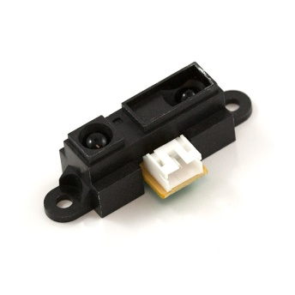

Other Sensors Tested and Decided Against:  
•Light Sensor – unpredictable due to sunlight and shadows  
•Capacitive Touch Sensor – unable to work through Plexiglas  
•PIR Motion Sensor – too much range, too sensitive  
•Digital Proximity Sensor – unnecessary to use I2C, size​

The Sharp GP2Y0A21YK was easily seen to provide the best results. It is an all-inclusive circuit because it comes with the additional required elements contained in its PCB at purchase. It runs off a Supply voltage of -.3 to 7 V. It has a distance range that would fit the application. More importantly, behind Plexiglas it would have a shorter distance range at our supply voltage that would give it a 15cm to 25cm range. It is very accurate and has the right sensitivity and voltage output that would work with our microcontroller. It was the sensor chosen for our application for these reasons.

**Audio Chip**

The design would require an audio chip to provide the audio sound of bird calls. Similar to what we did above with the sensors, a few audio chips were looked into as possibilities. The advisor recommended that the group decide upon and purchase three different audio chips, build the required circuitry and software for each, and determine which would work best in the design of the project.

The three chips used were the following:

* Nuvoton’s ISD3900 - The ISD3900 is a multi-message recorder featuring digital compression, comprehensive memory management, and integrated analog/digital audio signal paths.
* Nuvoton’s ISD1700 - The ISD1700 recorder is a high quality, fully integrated, single-chip multi-message voice record and playback device.
* Sparkfun’s Audio-Sound Breakout – WTV020SD - The WTV020SD is a small, simple IC for embedding audio-playback using a SD card.

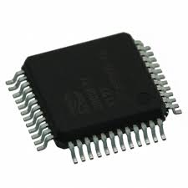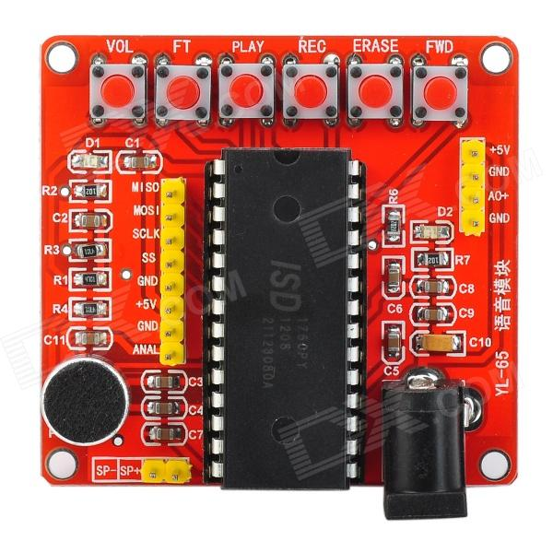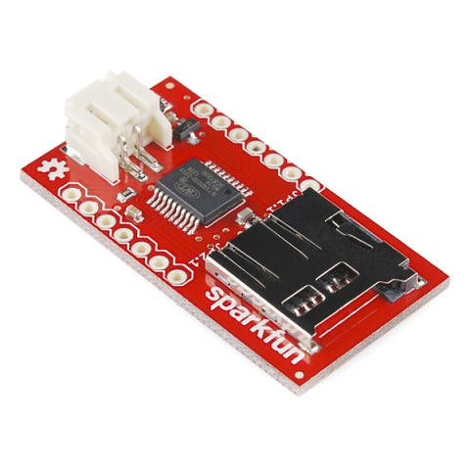

**ISD3900 ISD1700 Sparkfun Audio-Sound Breakout**

**ISD3900**

The ISD3900 had a lot of capabilities, however it was decided to not use this part. It is a surface mount chip and the time and energy required to solder it onto a custom PCB would be ambitious. The picture below shows the size of the chip in context of the tip of a pen.

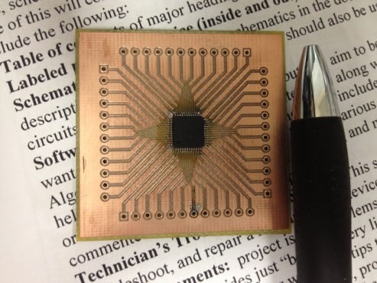

**ISD1700**

The ISD1700 has a lot of capabilities. It is a through-hole chip. It contains 120 seconds of onboard memory. It can record and playback sounds and is erasable. It is able to be used using standalone mode as well as SPI (serial peripheral interface) mode. Below is a picture of the breadboard used as testing was being done on it.

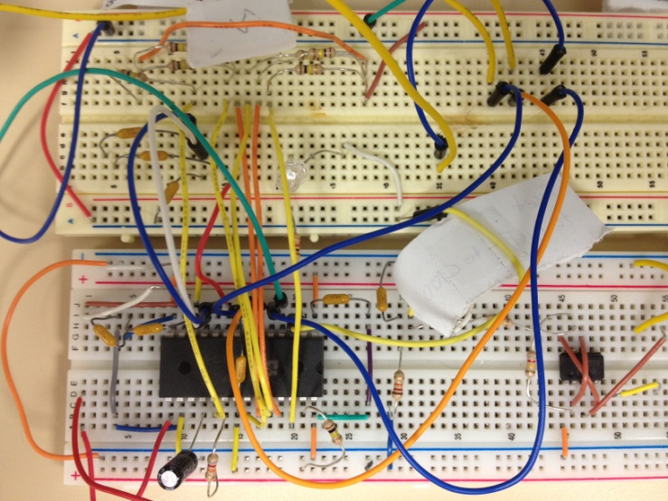

This chip was through-hole and so the group advanced farther in the testing process than the ISD3900 chip which was unusable as it was difficult to even mount it in a testable arena. With this chip, the group first addressed connecting it with the required hardware to a breadboard. The group followed the below example application circuit to connect the chip with the required hardware:

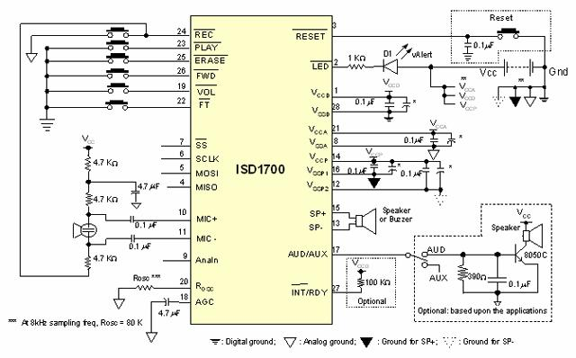

After the chip was connected, the group began accessing the functionality available via the standalone mode. When this was done, the group needed to figure out how to use SPI to send signals to the audio chip through the four SPI pins, CS, SCLK, MOSI, and MISO. The group had no former training in SPI so it was hardcoded in MPLAB. The datasheet was analyzed to find the proper addresses and signals that would need to be accessed and sent. The group was able to create all the required components, the hardware and software, for this chip.

The group was able to record a sound from the computer through AnaIn. The sound was recorded to a certain address on the memory of the audio chip. This memory could be played at will depending on the signal sent to it from the PIC18f4620. The group was able to record sounds from the computer as well as use a microphone to record voice sounds. Sounds could be erased depending on desired commands to the PIC18f4620.

This chip had many different capabilities available. The group learned an incredible amount through the testing of it. The problem with this chip was the on board memory. The on board memory would make it difficult for the user to have flexible uses, although it could be done, it would complicate the design. The use of the microphone would have been interesting but was unnecessary in relation to our requirements. In the end, this chip was not used.

**Audio-Sound Breakout – WTV020SD**

The group developed software to accompany the Sparkfun chip. One of the benefits of using this chip is that it came on a breakout board. The necessary hardware components to make it work were on board. Although this increased the cost slightly, it is still a worthwhile cost. This chip did not have on board memory. Instead, this chip used a micro SD card (the micro SD card reader is on board). Sound files had to be saved on the micro SD card in a specific way. These sound files had to be converted from mp3 or wav format to ad4 format. In addition, these files had to be numbered corresponding to the address they would be accessed by the audio chip. These would be stored within the range of 0000 to 1111, this chip is capable of playing 512 different sounds.

This chip is operable in standalone mode and also in a microcontroller dependent mode. This mode is similar to SPI mode, but doesn’t completely follow the protocol of SPI mode. When using this chip as a peripheral of the PIC the PIC will send a 16 bit address corresponding to the desired sound to be played, as labeled on the micro SD card. The Sparkfun chip will play a sound via the speaker + and speaker – pins or out of the PWM out pin, either can be used.

This chip was selected because it required less hardware components, decreasing the potential for hardware troubleshooting issues, and it allowed for sounds that could be formatted externally on the micro SD card. The sounds would not have to be recorded; they could be placed on the SD card and easily changed by putting the SD card into the computer. There could also be more sounds available than the ISD1700 chip.

**Buck Converter**

The BP5277-50 Buck Converter was used from ROHM Semiconductor. This Buck converter is capable of a maximum input voltage of 36 V and steps the voltage down to 5V. The group decided to use this because a voltage of 12 V or more was necessary to use for a power amplifier (topic to be discussed next) as well as a 5V power supply for our proximity infrared sensors and the PIC18F4620. This buck converter had the range we desired for input voltage, is a through-hole part, and provides the necessary functionality.

**Power Amplifier**

The AN5278 Panasonic Power Amplifier with Volume and Tone Control was chosen for our design. The audio chip from Sparkfun outputs only .5W so is not capable of driving the speaker at a great volume. The group then needed to use a power amplifier to increase the maximum volume of the speaker. The AN5278 has a 12V to 26V input, has correct temperature ratings, proper power dissipation, has a max power rating of 8W, and is capable of working with the speaker to produce proper sound volume. It provides the functionality the project needs and increases the volume to a level that meets our application. The level is also adjustable to provide flexibility.



**Afterthoughts related to Part Selection**

The length of this project means that the group will have increased knowledge of electrical engineering due to increased exposure to other classes, subjects, internships, and more. With the group’s increased knowledge there are decisions that would have been weighed differently. These include:

The choice of Microcontroller. The PIC18F4620 was the easy choice at the time as it was the only one the group had exposure to. Now, seven months later, a group member has taken Embedded Systems II and has been exposed to different microcontrollers. The group could have done more research into different microcontrollers and found a different microcontroller that may have met the application better.

The choice of audio chip. Looking back it could be much easier to choose an audio chip because the group now understands better what the project would require and better understands how to analyze and understand a datasheet. A different audio chip could have been chosen that could have provided the necessary memory, software protocol, volume, and functionality. The ISD1700 chip and ISD3900 chip also have breakout boards that could have been purchased. This would have taken away the hours spent understanding the hardware application of these circuits because they would have come with the application hardware on board.

## Design Methods and Decisions - Hardware Design / Schematic

This is a block diagram that describes the functionality of the hardware and circuits.

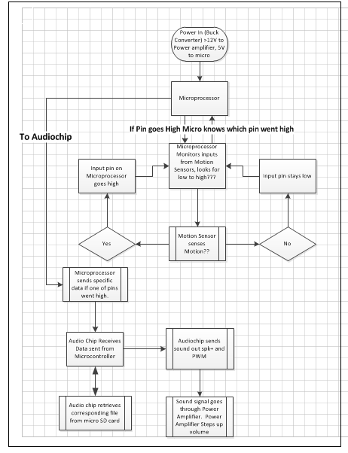

**Block Diagram 1: Hardware Process**

Here are the schematics for the hardware design.

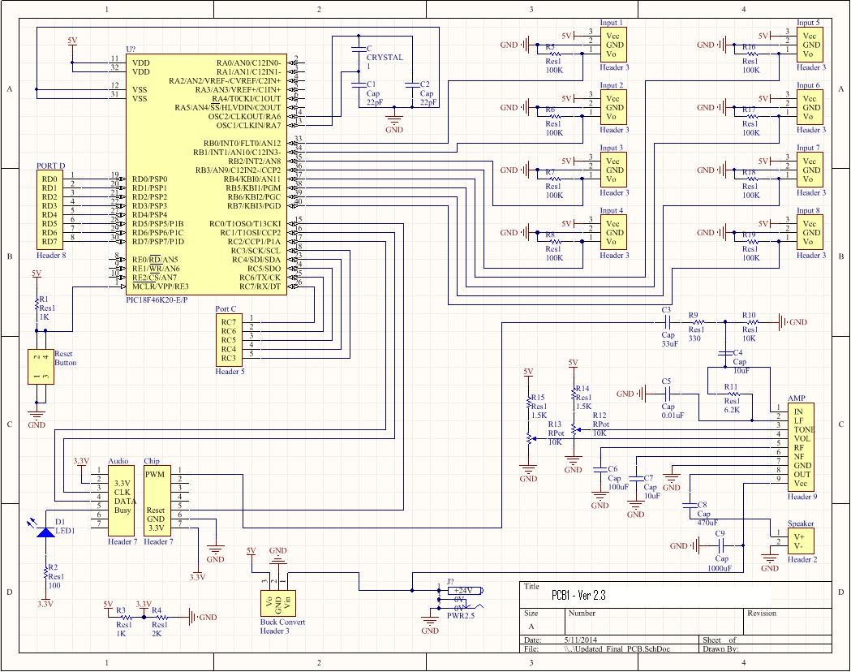

**Schematic 1: PIC, PIR inputs, audio, power Amp**

This Schematic contains the PIC in the upper left corner, the Inputs from the motion sensors in the upper right, the audio chip in the lower left, and the power amplifier and buck converter in the lower right corner.

In Addition:

The schematic shows a voltage divider used to step the voltage down to 3.3 V for the input to the audio board. After further analysis, the group observed that this was not a viable solution. The audio chip itself also has an internal resistance. This internal resistance would be in parallel with the voltage divider, causing this voltage to be unpredictable. This circuit is being replaced with two diodes in parallel or a 5V to 3.3V buck converter.

For PCB layout for Schematic 1 see Apendix.

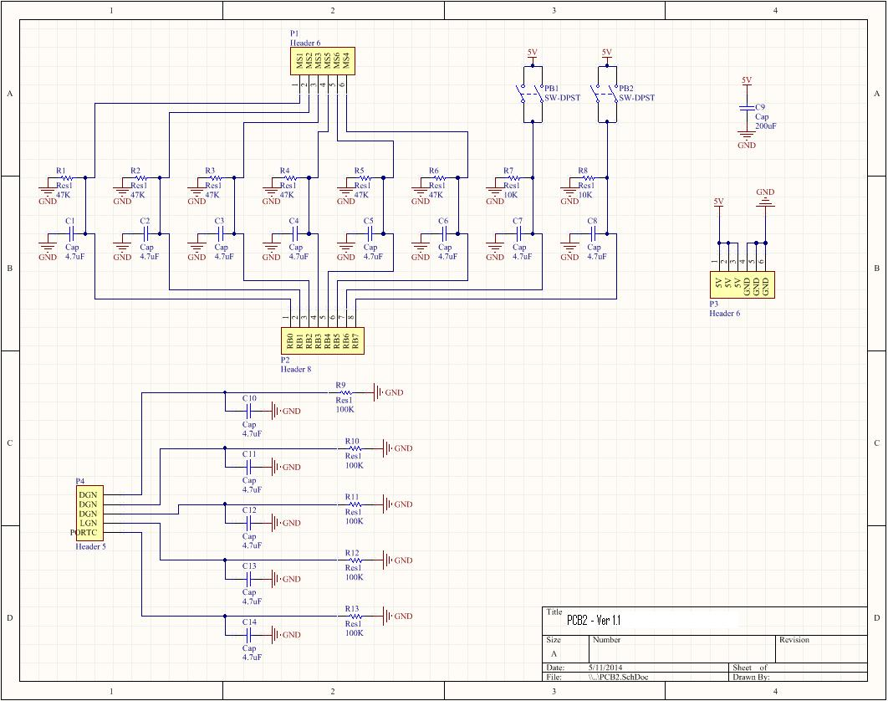

**Schematic 2: drop down resistors and capacitors**

This schematic shows the addition of drop down resistors and filtering capacitors that were used on inputs and outputs of the microprocessor.

For PCB layout for Schematic 2 see Apendix.

The group needed to place a **PIC18F4620** into the PCB. The PIC has the following PIN layout:

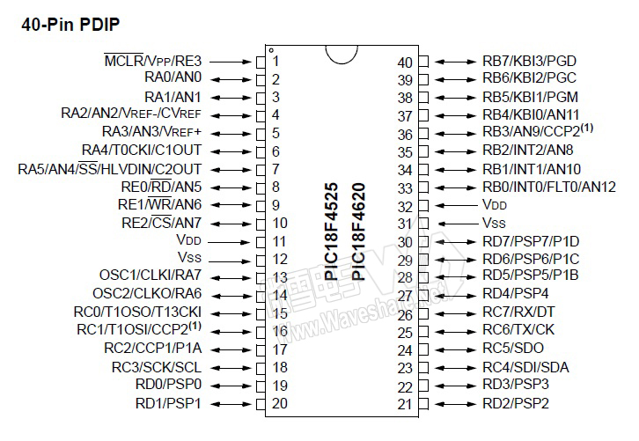

VDD represents the five volt input while VSS represents Ground. These were attached to each side. Pins RC0, RC1, and RC2 were used for DATA, CLK, and RESET to the audio chip. These pins were responsible for the signals sent to the audio chip containing the sounds to be played. Pins RB0 – RB7 are all input pins for the PIC. Six of these are connected to the six PIR sensors. The other two are connected to two buttons, allowing different interface applications with software.

Each of the eight input pins are connected to a 100k ohm drop down resistor as well as a 4.7uF capacitor. The PIR sensors send various noise without these capacitors there. This noise, if not filtered, can damage the PIC. Between the RB pins and the motion sensors is a 47k ohm resistor. This resistor drops the voltage from the motion sensors. This resistor lessens the distance range of the PIR sensors and makes them less sensitive to triggering the PIC.

The RC0/1/2 pins connected to DATA, CLK, and RESET have the same drop down resistor along with filtering capacitor.

The RESET Pin, pin 1 of the PIC, is also connected to a drop down resistor and a filtering capacitor. The unused input/output pins of the PIC are also connected in parallel to a drop down resistor and a filtering capacitor.

These resistors and capacitors were used because good design practices would lay out that pins should not be left floating but should be grounded in some way. These pins were experiencing large noise variances seen on an oscilloscope with voltages getting as high as 16V peak to peak. These voltages can damage the PIC, and the capacitors fix this problem.

The **Sparkfun Audio Breakout Board** contained the necessary hardware on board. The pins on the Audio board are seen in the following image:

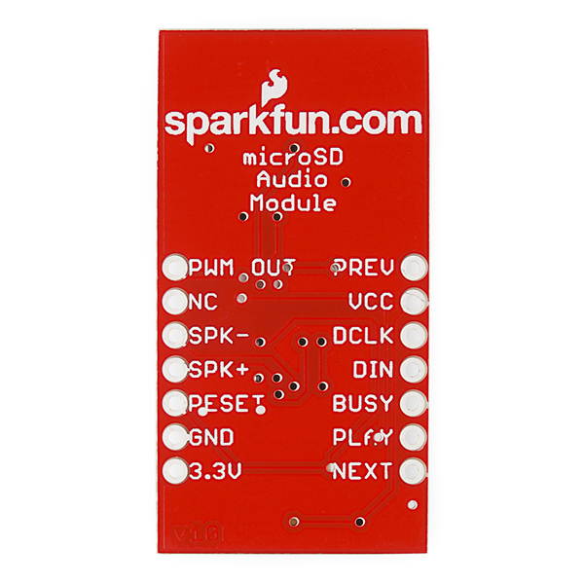

* PWM Out is connected to the input pin of the Power amplifier to amplify the volume of the audio wave.
* NC means not connected and can be left floating.
* SPK- and SPK+ can be connected directly to a speaker.
* RESET should be connected to RC0 of PIC.
* GND should be grounded.
* 3.3V should be connected to 3.3V. This voltage will come from the 5V from the Buck converter. This 5V power supply will be stepped down either by two diodes in series or by a 5V to 3.3V buck converter.
* PREV is used for standalone mode and will be left not connected.
* VCC will be connected to 3.3 V.
* DCLK will be connected to RC1 of the PIC.
* DIN will be connected to RC2 of the PIC.
* BUSY is used with a 100 ohm resistor and LED coming from 3.3V. This PIN will go high when the audio chip is playing a sound. It will be low when not playing one and the LED will be on.
* PLAY is used in standalone mode and will not be connected.
* NEXT is used in standalone mode and will not be connected.

The Design used the **AN5278 Power Amplifier**. Below is an example circuit:



Each of the pins was connected to the proper capacitance and resistance as described. The group did not use the lower circuit with the transistor, 100 ohm 330 ohm and 47uF capacitor. Our input wave, PWM OUT, from the audio chip was connected to the 33uF capacitor and resistor as shown at pin 1. WE connected potentiometers at pin 3, TONE, and pin 4, VOLUME. The input voltage at pin 9 can be between 12V and 36 V. This voltage comes from the adapter used to step down the wall output voltage.

**Afterthoughts related to PCB and schematic Design. (Lessons Learned)**

The group made mistakes in relation to the PCB creation. Certain circuits work when used on a breadboard but behave differently when used in a PCB application. The pins of the PIC behave differently. The group initially burned out two PIC processors during testing when using the externally ordered PCB. After this happened tests needed to be run to see what the problem was. It was decided upon that possibly the problem was a result of the PIC18F4620 having pins without routes to ground. When the pins were examined the group saw images on the oscilloscope that had large voltage noise ranges. These had to be filtered out. The group conducted a lengthy test to fix this problem. Below is an image of the test taking place:

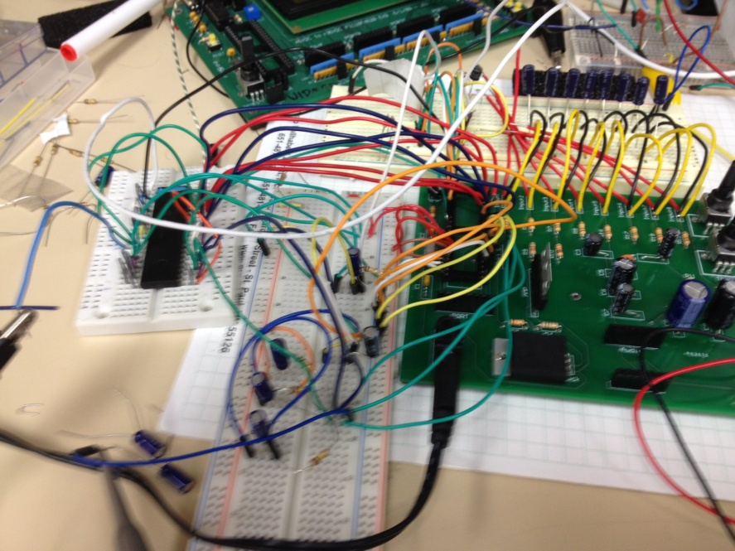

After running this test the group found that the PIC would work if drop down resistors and filtering capacitors were used. This is why the additional PCB was needed. The group created this PCB after the initial PCB was ordered. This PCB is connected through wires as can be seen in the finished product.

As we were testing the ordered PCB similar problems were also being seen with the connection of the PIR sensors. The group was seeing large voltage ranges from the motion sensors that were attached at the inputs when there was no capacitor. This voltage noise was causing the audio board to not function properly, and was sending undesired signals to the PIC. Capacitors were placed here along with resistors in series with the PIR sensors to step down the voltages.

With these problems taken care of a new PCB could have been ordered to meet the entire needs of the design. However, an attached PCB was the most desirable solution that could meet the project deadline.

The routing of the PCB was also something we needed to take into consideration as well as the footprint sizes of components.

## Design Methods and Decisions – Software Design

The software was designed to be used with the Sparkfun’s Audio-Sound Breakout – WTV020SD. This chip calls for the following protocol, as seen in the timing diagram below.



Some observations:

* RESET and CLK start high. DATA starts low.

*To send the signal:*

* A brief high-to-low-to-high on the RESET pin with a duration of 5ms.
* A 300ms duration where CLK stays high post reset.
* Then CLK goes low for 2ms followed by CLK toggling, 16 bits. (it was found that the duration of the toggling does not need to be 200us)
* DATA is sent depending on which address is desired to be played. This translates to meaning high signals coming dependent on which wd4 file to be accessed on the SD card. These can range from binary numbers of 0000 0000 0000 0000 to 0000 0000 1111 1111.
* BUSY pin goes high while signal is being sent and sound is playing.

This shows the following port declarations as defined in the software file for this project. As can be seen TRISB = 0xFF making all the pins for port B of the PIC inputs. These are the pins used in hardware by the proximity infrared sensors. Also of importance, RRISC = 0x70, this makes pins 0, 1, 2 output and the rest of port C input. The other pins are output pins. These could be easily altered to account for more input or output pins.

void main(void)

{

unsigned long int i;

unsigned int TIME;

TRISA = 0;

TRISB = 0xFF; //THIS MAKES ALL PINS ON PORTB INPUT

TRISC = 0x70; //TRISC = 0xF0; // Make bits 0..2 of PORTC output and port 7, 0111 0000, 3-6 are input

TRISD=0x00; //THIS MAKES ALL PINS ON PORTD OUTPUT

TRISD = 0;

TRISE = 0;

ADCON1 = 0x0F;

PORTA = 0;

PORTB = 0;

PORTC = 0;

PORTD = 0;

PORTE = 0;

TIME = 0;

**CODE 1: Port Declarations**

This shows the variable definitions that correspond to the addresses sent on the DATA line to the audio chip. As can be seen, the variable names have comments containing which bird calls they correspond too on the display. These variables could easily be altered to change the sounds played. Also shown, are the initial conditions of the RC pins.

// initial conditions

RC0=1; // RESET is high

RC1=1; // CLK is high

RC2=0; // DATA is low

RC7=0 // setting rc7 as 0 because for some reason was going high by default

int STOP=0xFF; //0xFF //Stops a play or record, etc

int ZERObyte=0x00; // Northern Pintail //FOR ADDRESS 0000 0000

int TESTB=0x80; // Eastern Screech Owl //FOR ADDRESS 0000 0001

int Third=0x40; // Canadian Goose //FOR ADDRESS 0000 0010

int FOURTH=0xC0; // Bar Headed Goose //FOR ADDRESS 0000 0011

int FIFTH=0x20; // Bald EAgle //FOR ADDRESS 0000 0100

int ADDone=0x00; // American Kestrel //FOR ADDRESS 0000 0101

int lastBYTE=0;

int RANDOM=0;

int PINTAIL=0;

while(1) {

**CODE 2: Variable definitions and initial Conditions**

Below is example code showing the sending of an address signal from the PIC to the audio chip. Pin RB1 is connected to a proximity motion sensor. When the output voltage of the proximity sensor goes high the PIC will enter this section of the software. It will then run through the lines of code. It will set RC0 (RESET pin) low for 5 ms before bringing it high again. Then, it will wait for 300ms before bringing RC1 (CLK pin) low. It will then wait 5ms before sending the 16 bit data binary signal in the called functions SPI_WriteByte() and SPI_WriteByteSEVEN(). These functions will be described below and send a binary signal depending on the variable passed into it, in this case 0x00. Then it will enter the last if statement, compare ZERObyte AND 1 to see if it is equal to 1. If it is, it will bring RC2 (DATA pin) high. Then, after a brief wait, RC2 (DATA) will be brought low and the function will stay inside this wait function for the duration of the audio sound being sent.

if(RB1=1)//Northern Pintail

{

RC0=0; Wait_ms(5); //toggle RESET high-low-high

RC0=1; Wait_ms(300); //increasing post reset delay

RC1=0; Wait_ms(5); //start clock with a 5 ms valley

//RC6=1; //clk is high again

SPI_WriteByte(ZERObyte); //sends 0x00

SPI_WriteByteSEVEN(ZERObyte); //sends 0x00 - address 0 of 512

if(ZERObyte&1==1) {RC2=1; Wait_ms(2);} else{ RC2=0; Wait_ms(1);}

RC1=1;

Wait_ms(1); //this wait command allows the clock to rise while data is still high,

//so that it isn't exactly on the rising edge

RC2=0;

Wait_ms(3043); // Specific Time related to this Sound.

//wait_noInterfere();

//makes others wait a certain number of ms without interferance

}

**CODE 3: Sending Audio File Address**

The below code is the function SPI_WriteByte(). The comments describe the process. It sends a byte (8 bits) to the RC2 (DATA pin). While it does this CLK toggles so that data is sent out on the CLK rising edge.

void SPI_WriteByte(int byte2, int i) {

for(i=0; i<8; i++){

if(byte2&1==1) {RC2=1; Wait_ms(1);} else{ RC2=0; Wait_ms(1);} // if byte2 AND 1 = 1, DATA is 1, if not DATA is 0

RC1=1; // set CLK high

Wait_ms(1); // wait 1 ms

RC1=0; // set CLK low

Wait_ms(1); // wait 1 ms, these four lines creates the toggle step diagram for CLK.

byte2=byte2>>1; // this takes byte2, a binary number, and movesa zero on the leftend

// for example 1111 0000, would become 0111 1000

// this allows the variable to represent a binary waveform you want to send, allows the code to send it

}

}

**CODE 4: SPI_WriteByte()**

The below code is the function SPI_WriteByteSEVEN(). It has the same function as the above code, only that it only sends seven bits instead of 8 bits.

void SPI_WriteByteSEVEN(int byte2, int i) {

for(i=0; i<7; i++){

if(byte2&1==1) {RC2=1; Wait_ms(1);} else{ RC2=0; Wait_ms(1);} // if byte2 AND 1 = 1, DATA is 1, if not DATA is 0

RC1=1; // set CLK high

Wait_ms(1); // wait 1 ms

RC1=0; // set CLK low

Wait_ms(1); // wait 1 ms, these four lines creates the toggle step diagram for CLK.

byte2=byte2>>1; // this takes byte2, a binary number, and moves a zeroon theleft end

// for example 1111 0000, would become 0111 1000

// this allows the variable to represent a binary waveform you want to send, allows the code to send it

}

}

**CODE 5: SPI_WriteByteSEVEN()**

Below is the code that would be used if the address signal to be sent contained a 1 in the last bit. The following code would be used to ensure that the code performed correctly on the last bit. The reason being that for the last bit the audio chip requires that RC1 go high and RC2 go low. As can be seen, it defines a new variable to represent the last bit.

if(RB2=1)//Eastern Screech Owl

{

if (TESTB >>7 == 1) {lastBYTE =1;} else {lastBYTE=0;}

// if statement needed, SPI_WriteByteSEVEN doesn't return byte2

RC0=0; Wait_ms(5); //toggle RESET high-low-high

RC0=1; Wait_ms(300); //increasing post reset delay

RC1=0; Wait_ms(5); //start clock with a 5ms valley

**CODE 6: last bit modification**

This Block Diagram may describe the execution of sending a 16 bit address better as described in the SPI_Write functions.

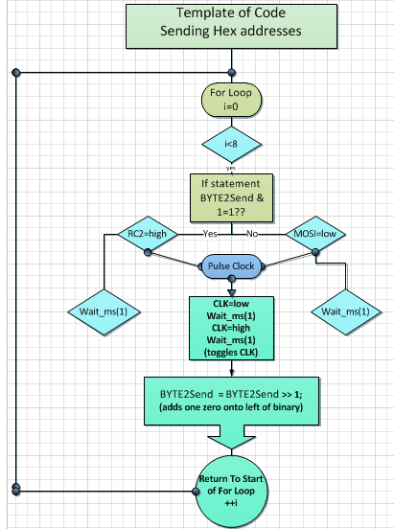

The code can be modified in many different ways. It’s structure is simple enough and integrates the use of calling methods so that more sensors could be added easily, different output and input port pins could be defined, different sounds could be played by modifying the variables, and much more.

**Afterthoughts related to Software Design**

The creation of the software could have been made easier if the group had figured out the process of calling function in the main function as done using the SPI_Write() functions. This greatly simplified the code. It made it much easier to look at and made it much more flexible. In this way instead of having to change each if statement that contained the code you could just change the one at the bottom.

As mentioned earlier the group could have chosen to use a different microprocessor. This could have changed the method in which the group went about sending the address protocol. However, another thing that was thought of is if we had done further research into how to use the SPI functionality of this microprocessor. This could have been done instead of hardcoding it.

Also, the group discovered that the audio chip would have problems with its functionality when the PIC didn’t wait until the audio file had played from start to end. For this reason, the group added wait functions at the end of each of the address sending statements according to the length of the audio sounds. This prevented the audio sounds from being interrupted by other PIR sensor linked pins being activated.

## Design Methods and Decisions – Enclosure Design

This project requires an enclosure. The enclosure is a large part of the project. The enclosure should fulfill the requirements, specifically being aesthetically pleasing, weather proof, and being proper size and weight.

The group considered many different options. The group considered 3D printing, considered fabricating one of wood and Plexiglas, and looked into many different types of metal enclosures. The group finally found and decided upon using two 37 by 43cm enclosures and securing them together to give a total dimension of 75cm width by 43cm height by 12cm depth. The enclosures were made of aluminum.

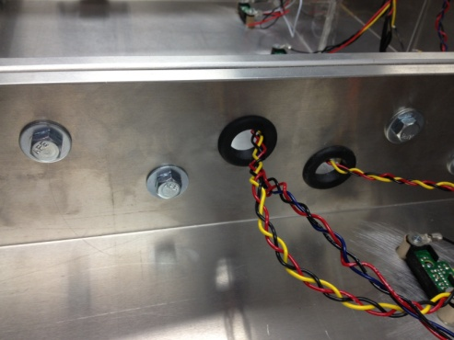

They were combined by drilling holes and using bolts in the center piece. A hole was cut so that the motion sensors could run to the other side without being run outside of the enclosure.

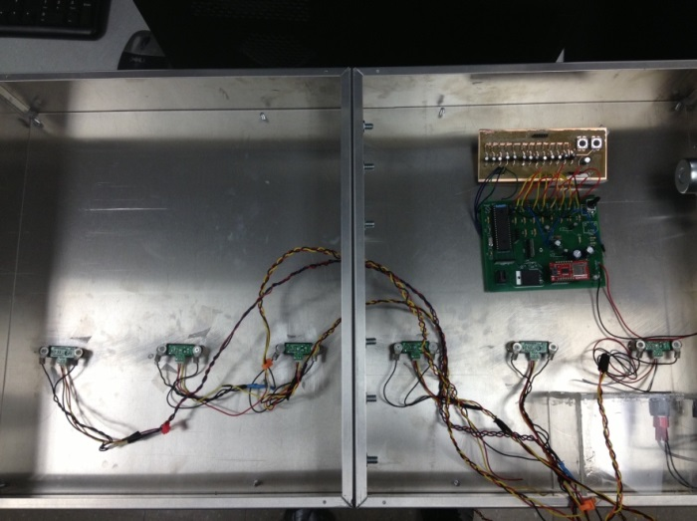

Holes were also drilled into the front of the enclosure so that the motion sensors could be used. Plexiglas was used on the front to protect the poster as well as the exposed motion sensors. The sensors were mounted using wood fixtures with screws to secure the sensors. The PCB was attached to the enclosure using mounting tape. The power supply outlet was mounted on a plastic casing along with a breaker to allow you to control the power.

The enclosure is weatherproof and sealed from the outside environment. The enclosure is sealed on the back side by the metal enclosure covers.

## Project Development Timeline

1. Theoretical Design
2. Breadboard of audio chip connected to ECE 376 development board. Software validation.
3. Addition of breadboard for power amplifier, buck converter.
4. Addition of breadboard for the PIC18F4620, replacing the development board.
5. Using first in house PCB, noting problems and making changes to out of house PCB order.
6. Building circuit on out house PCB.
   1. Starting with PIC184620. Noted need for resistors and capacitors, adding them via breadboard, making additional PCB for final prototype.
      1. Validate working.
   2. Adding Proximity Motion Sensors. Noting need for resistors and capacitors. Adding them via breadboard. Making additional PCB for final prototype.
      1. Validate working.
   3. Adding Sparkfun Audio playback chip.
      1. Validate working.
   4. Added Power amplifier.
      1. Validate working.
7. Project Completion.

## Budget

The group came in slightly above the budget. For specific budget calculations see appendix.

## Troubleshooting Section – Technician’s Guide.

This section will detail some of the possible troubleshooting that will be required if the unit becomes dysfunctional.

**Possible Problem 1:** There is a possibility that one audio sound will be continually playing on repeat, without letting any of the other sounds play. To troubleshoot this issue, first check to see whether there is anything in the visual scope of the Proximity Sensor that could possibly be activating it continuously. Next, if this was not the problem, use an oscilloscope to check the voltage either at the 100k ohm resistor at each of the RB pin inputs or across the 100 k ohm resistor and the 47 k ohm resistor in series with the PIR sensor. One of the six sensors may be functioning improperly or is sending too high of a signal. The sensor may need to be replaced or resistors adjusted.

**Possible Problem 2:** There is a possibility that no audio is being played from the unit. To troubleshoot this issue, first open up the unit from the back so that you can visually access and see the PCB. Have the unit powered on. Check to see if the audio chip is getting 3.3 V. The pin description is contained in this technical brief. If it is not getting 3.3 V, there may be a problem with your power supply. If it is getting 3.3 V, look to see whether the LED is on. If the LED is not on, it is possible that your audio chip is no longer making connection to the header or that your audio chip burnt out, however, this should not happen. If the LED is on, wave a hand in front of one of the motion sensors. If nothing happens, you will need to use an oscilloscope to see if your motion sensors are operating correctly and bringing the RB pins on the PIC18F4620 high. If they are, then you will want to use an oscilloscope to view the waveform being sent by RC1 and RC2, the CLK and DATA pins of the micro. If these aren’t being sent by the microprocessor then the PIC may be damaged, try replacing it and loading software onto it. If the PIC is sending CLK and DATA signals then visually examine the LED. If, when the PIC sends a DATA signal the LED blinks of briefly and comes on again with no audio, then you will need to view the micro SD card to see if it is damaged, however this should not happen. If the LED turns off for an approximate three second duration and there is still no audio sound, then you will need to examine the power amplifier circuit. Ensure that it is getting the proper input voltage from the buck converter, examine capacitances, and the potentiometers to make sure they are not damaged and dysfunctional. Then, examine the speaker to verify it is not damaged. The speaker should have voltage across it while being played.

## Project Comments

**Lessons Learned and Problems**

Some lessons learned are already included in the above sections. These lessons are labeled “Afterthoughts related too..” And can be found at the end of the Part Selection section, the Hardware Design section, and the Software Design section.

Some additional problems and lessons learned are the following:

* Some datasheets are very non informational and cryptic to read.
  + The datasheet for the Sparkfun audio chip was written very poorly.
* Being ahead of schedule can benefit you in many ways and save time when needing to do critical tests.
  + The group had moments where the group was moderately low on time and so did not possess the time to redesign certain errors.
* Find good tools, such as oscilloscopes that can make measurements quicker and easier.
* Don’t underestimate the need for drop down resistors and filtering capacitors.
* Circuits can behave differently on a PCB than they do on a breadboard.
  + The circuit worked completely without the need for drop down resistors and filtering capacitors and was only found necessary when using the PCB.
* Some errors aren’t design related, but faulty component related.
  + A potentiometer was keeping the Power amplifier from working.
* Use a thermal camera when testing to make it easier to understand the thermal characteristics of the PCB.
  + This allowed the group to see any thermal issues related to the PCB design.
* Maximize the intelligence and experience of an advisor and the faculty in the Electrical department.
  + The group did use the advisor but the advisor could have been used even more.

**Future Improvements**

Future improvements could include any of the following:

* One uniform PCB. The final product uses two PCBs, one main PCB for the majority of the components, and one additional PCB for drop down capacitors and resistors for the PIC18F4620 pins. If more time was available and improvement could be joining these two.
* More sounds could be used along with added flexibility. The sound files are related to binary addresses sent to the audio chip by the PIC. Steps could be taken in software to enable the user to change certain sound waves in sets of six without having to alter the files in the micro SD card. There is also large flexibility related to how the motion sensors could be defined. Certain PIR sensors could be tied to code that would play a random song that is located on the audio file.
  + The sounds could also be changed in order to make it similar to a quiz. Instead of wave a hand and play a sound it could be wave a hand play a sound and guess what sound it is. In a sense there could be a mystery bird.
* An LCD interface could be used. This could have current weather conditions but could also work in relation to the PIC to display information about the bird of whose sound is being played. This would not be difficult to introduce and would add a large improvement.
* LEDs could be placed in similar locations as their corresponding motion sensors. Then when one PIR sensor is activated an LED could light up that bird whose sound is being heard on the poster.
* Future improvements could also include audio chips that had the capability for recording.

**Future Projects**

Future projects that could be derived from this could include a similar project but one that is used in a different application. The applications of a motion activated audio display are not solely in zoo settings. These could be used for marketing purposes, museums, and much more. This project can be the base for future projects that could include Bluetooth as discussed earlier. IF the application was more complex in the information that it involved a Bluetooth cell phone app could be very reasonable in addition to a similar display. A Bluetooth app would allow you to have a much larger array of flexibility and information.

**Tips to New Design Students**

Tips that the group would recommend to incoming design students would include the following:

* Choose a project that you find interesting, but also place part of the weight of your decision upon the advisor who is supporting that project. This group’s advisor greatly helped our project. A good advisor will make a project much more enjoyable, even if you think you aren’t as interested in the project description.
* Work in a group of three. A group of three is easier to manage, easier to make decisions, easier to divide the task evenly, allows you to understand all aspects of the project, and allows you to have a smaller project.
* Understand that choosing a project that is largely software based may be difficult and entail a large learning curve, but is much easier to troubleshoot than hardware problems. Software doesn’t lie, it is black and white, and either will work or not. Hardware can be designed in theory but have different results in physical reality.
* Work on your project when you have large sections of time. This will allow groups to make large amounts of progress at once instead of pausing and picking up where the group left off again and again.
* Maximize the knowledge of the supporting faculty in the department. Dr. Schroeder can be a great help as well as Jeff.
* Try to use good design methods. This means that even though your budget is somewhat flexible, in an industry application your design will need to be as cost effective as possible.
* Lastly, Choose a project that you will enjoy working on. Senior design is stressful at times but getting to see a project completed from inception to prototype is a lot of fun. You will learn a lot so enjoy the ride and get a lot from it.

## Conclusion

This project has now been completed according to timeline projections and budget projections. The project has fulfilled the necessary requirements and includes the functionality desired. This document describes the process in full. The requirements, the complete design, the parts selected, the test process, the problems faced and lessons learned, and additional supporting documents.

### Special Thanks

Special thanks go to the NDSU department of electrical and computer engineering for providing the coursework and resources to make this project possible. Special thanks go to Advisor Dr. Glower for guiding the project and providing experience and insight that made the project able to be completed. Lastly, special thanks goes to the Red River Zoo for having the idea that the project is based upon.

## Appendix

Included :

* Parts List
* Budget
* PCB design1, PCB design2
* Front Page of Component Datasheets
* Software Source Code

**Parts List**

|  |  |  |  |  |
| --- | --- | --- | --- | --- |
| **Qty** | **Purch** | **Part** | **Retail** | **Acquired** |
| 1 | Y | PIC18F4620 | 6.25 | 6.25 |
| 1 | Y | SD Interface Break Out Board | 9.99 | 9.99 |
| 7 | Y | IR Proximity Sensor | 13.95 | 13.95 |
| 1 | Y | Weather Resistant Speaker | 6.95 | 6.95 |
| 1 | Y | Audio Break Out Board | 19.95 | 19.95 |
| 2 | Y | Potentiometer | 1.08 | 1,08 |
| 1 | Y | Power Supply | 12.30 | 12.30 |
| 2 | Y | Hammond Chassis – 17”x15” | 51.75 | 51.75 |
| 2 | Y | Hammond Chassis Covers – 17”x15” | 15.30 | 15.30 |
| 1 | Y | Poster Display | 19.00 | 19.00 |
| 3 | Y | In-House PCB | - | 0.00 |
| 1 | Y | Final Order-Out-Of-House PCB | 52.21 | 52.21 |
| 1 | Y | AN5278 Power Amplifier | 1.62 | 1.62 |
| 1 | Y | BP5277-50 Buck Converter | 7.50 | 7.50 |

**Budget**

|  |  |  |  |  |  |
| --- | --- | --- | --- | --- | --- |
| **Qty** | **Purch** | **Part** | **Retail** | **Acquired** | **Total** |
| 1 | Y | PIC18F4620 | 6.25 | 6.25 | 6.25 |
| 3 | Y | PIC18F4620 | 6.25 | 0 | 0 |
| 2 | Y | Light Sensors | 1.83 | 1.83 | 3.65 |
| 2 | Y | PIR Motion Sensors | 10.26 | 10.26 | 20.52 |
| 2 | Y | Digital Proximity Sensors | 4.07 | 4.07 | 8.14 |
| 2 | Y | Barometer Sensor | 2.74 | 2.74 | 5.48 |
| 2 | Y | Humidity Sensor | 4.32 | 4.32 | 8.64 |
| 1 | Y | SD Interface Break Out Board | 9.99 | 9.99 | 9.99 |
| 7 | Y | IR Proximity Sensor | 13.95 | 13.95 | 97.65 |
| 1 | Y | Weather Resistant Speaker | 6.95 | 6.95 | 6.95 |
| 2 | Y | Audio Break Out Board | 19.95 | 19.95 | 39.9 |
| 1 | Y | ISD1760 Audio Chip | 7.9 | 7.9 | 7.9 |
| 2 | Y | ISD3900 Audio Chip | 4.23 | 4.23 | 8.46 |
| 3 | Y | Potentiometer | 1.08 | 1.08 | 3.24 |
| 2 | Y | Step Down Buck Converter | 7.5 | 7.5 | 15 |
| 5 | Y | Audio Amplifier | 1.62 | 1.62 | 8.1 |
| 1 | Y | Power Supply | 12.3 | 12.3 | 12.3 |
| 2 | Y | Hammond Chassis – 17”x15” | 51.75 | 51.75 | 103.5 |
| 2 | Y | Hammond Chassis Covers – 17”x15” | 15.3 | 15.3 | 30.6 |
| 1 | Y | Poster Display | 19 | 19 | 19 |
| 3 | Y | In-House PCB | - | 0 | 0 |
| 1 | Y | Final Order-Out-Of-House PCB | 52.21 | 52.21 | 52.21 |
|  |  |  |  |  |  |
| 2 | N | Audio Break Out Board | 19.95 | 19.95 | 39.9 |
| 1 | N | 2GB microSD Card | 3 | 3 | 3 |
|  |  |  |  |  |  |
|  |  |  |  |  |  |
|  |  | Total Spent |  |  | 467.48 |
|  |  | Total Unspent |  |  | 42.9 |
|  |  |  |  |  |  |
|  |  | Grand Total |  |  | 510.38 |
|  |  | Total Spent | $444.38 |  |  |
|  |  |  |  |  |  |
|  |  | Total Unspent | $42.90 |  |  |
|  |  |  |  |  |  |
|  |  | Grand Total | $487.28 |  |  |
|  |  | Original Budget Requested | $652.33 |  |  |
|  |  | Original Budget Approved | $500.00 |  |  |

**PCB Design 1 - Layout Main Components**

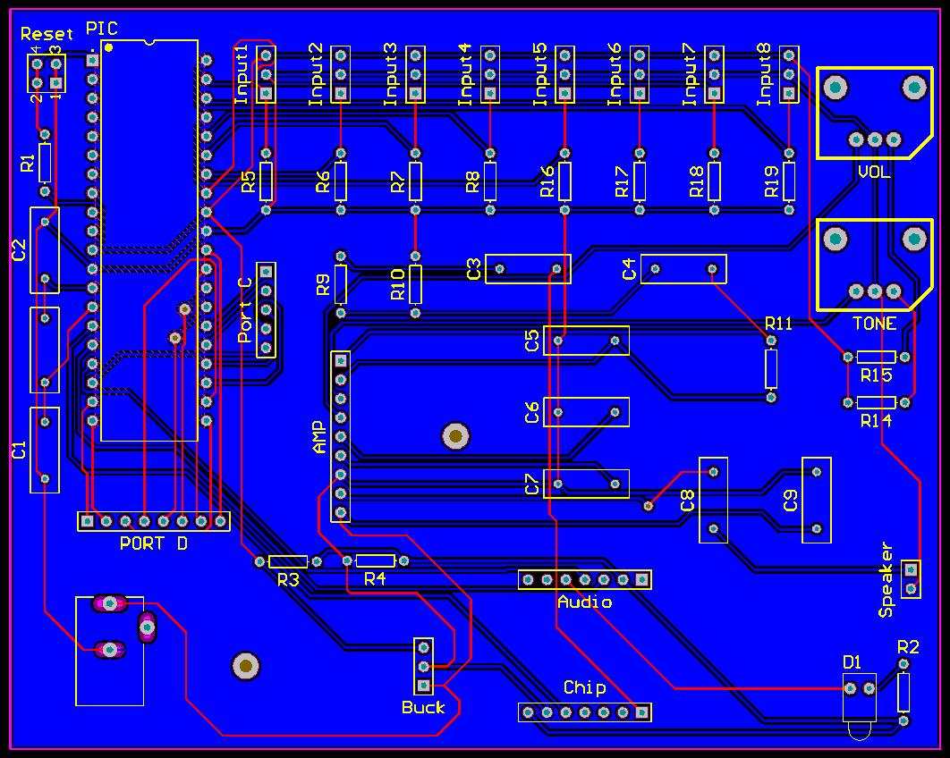

**PCB Design 2 – Additional PCB, drop down resistors and filtering capacitors**

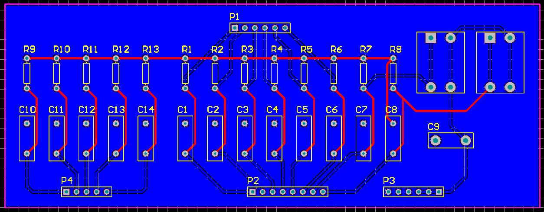

**Component Datasheet**

